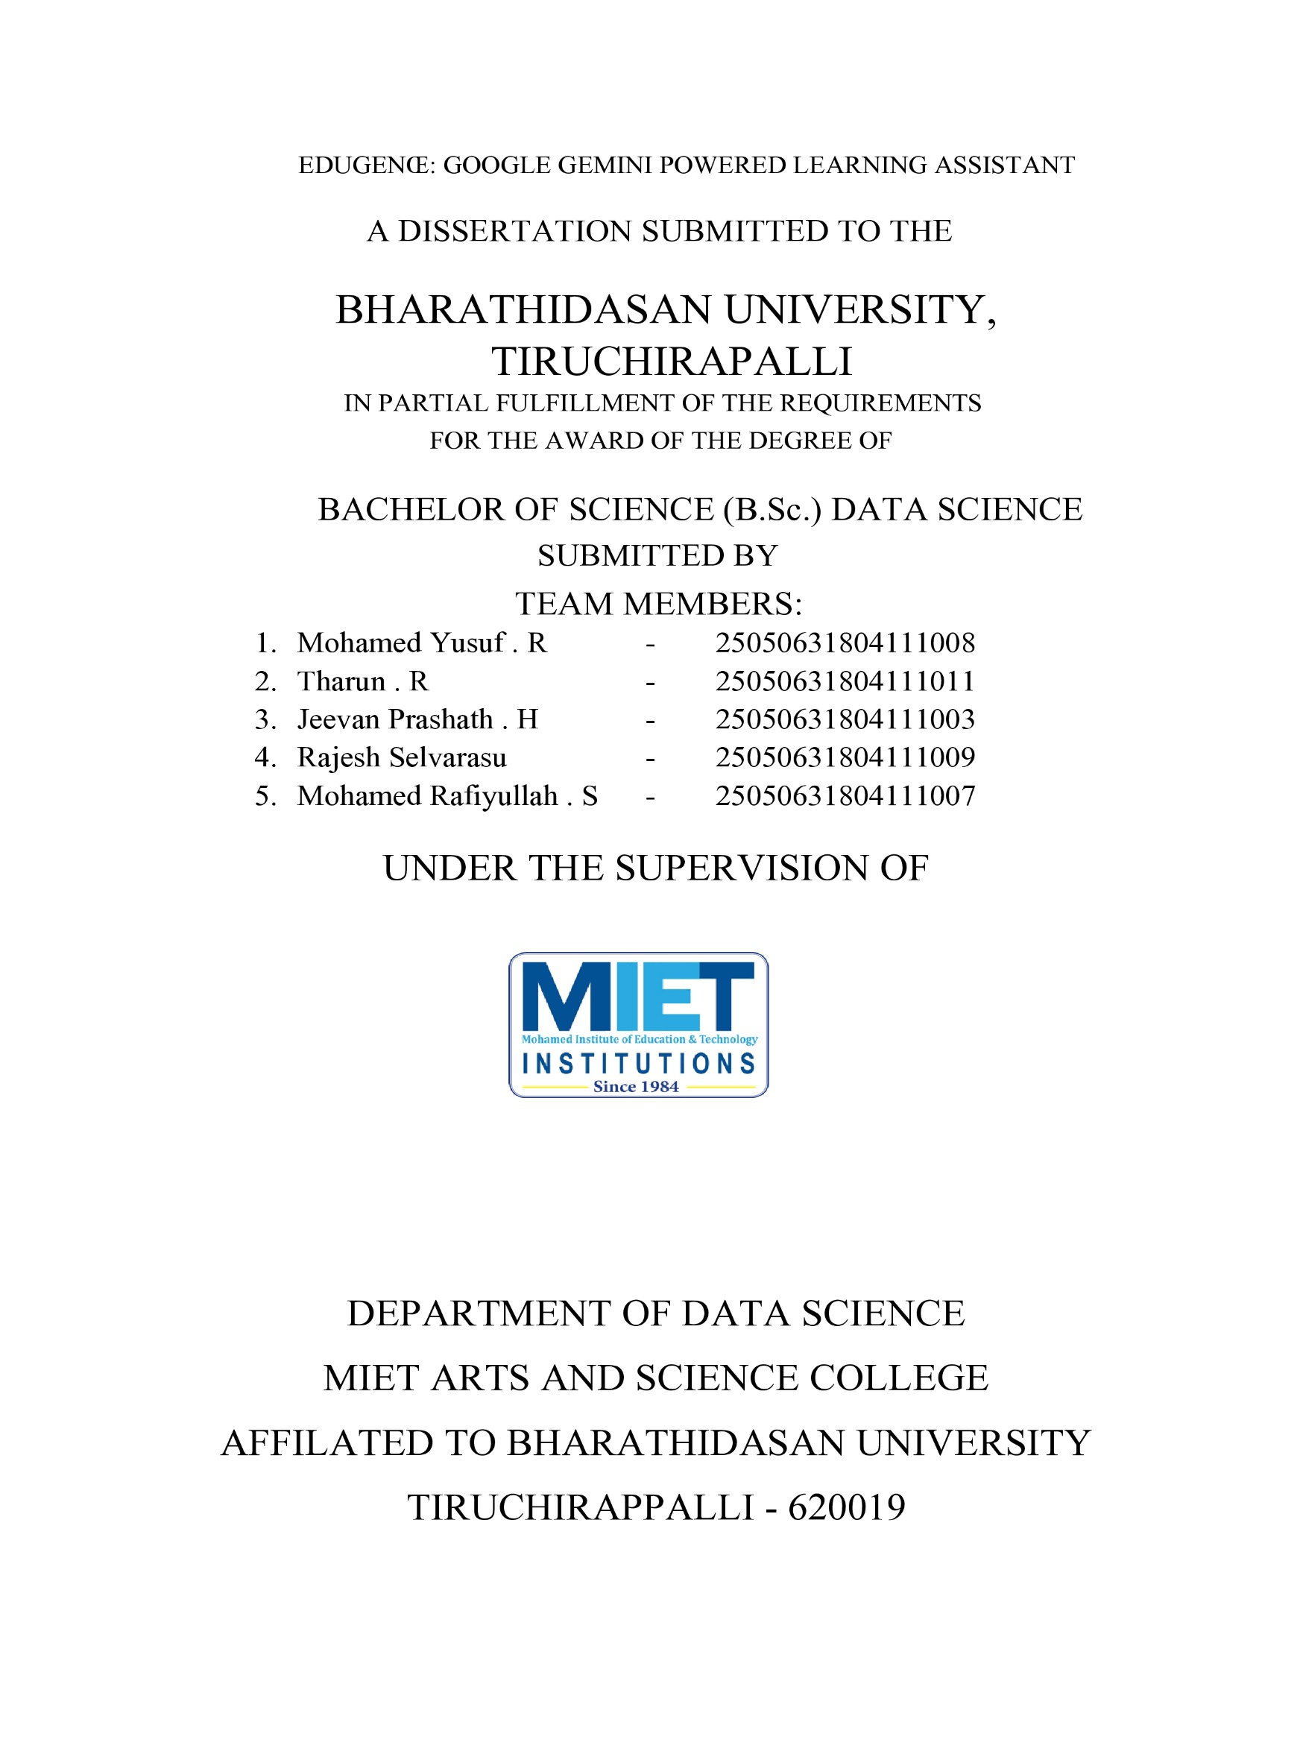
 Brainstorming and Idea Prioritizing

Date | 30 SEPT 2026
Team ID | SWTID-2026-9948
Project Name | EduGenie – Google Gemini Powered Learning Assistant
Maximum marks | 3 Marks


Step 1: Brainstorm and Idea Listing
S.NO | Team Member | Idea/Suggestion | Category
1 | Tharun R | AI-powered educational question answering using Google Gemini | Generative AI
2 | Jeevan Prashath H | Prepare comprehensive project documentation, including project proposal, reports, workflow, user manual, and technical documentation to support project development and presentation. | Documentation
3 | Rajesh Selvarasu | Personalized learning recommendations based on student interests | AI / NLP
4 | Mohamed Rafiyullah S | Quiz generation and educational summarization platform | Education Technology

Step 2: Idea Prioritization
Final Idea | Feasibility  (High/Medium  /Low) | Importance  (High/Medium  /Low) | Priority | Selected  (Yes/No)
AI Educational Assistant | High | High | 1 | Yes
Learning Recommendation Engine | High | High | 2 | Yes
Quiz Generation Platform. | High | Medium | 3 | Yes

